**ST. XAVIER’S COLLEGE**

**(Affiliated to Tribhuvan University)**

Maitighar, Kathmandu



**Database Management System**

**Lab Assignment #3**

**Submitted by:**

Arun Sanjel  
013BSCCSIT010

**Submitted to:**

|  |  |
| --- | --- |
| **Er. Sanjay Kumar Yadav**  Lecturer  St. Xavier’s College |  |

**Date of Submission:** August 3, 2015

**Additional Advantages of Database approach**

A Database Management System (DBMS) is basically a collection of programs that enables users to store, modify, and extract information from a database as per the requirements. The advantages of DBMS are given below:

**Expandability/Flexibility**

DB approach has great advantage of expandability and flexibility as new table, records , data or user can be inserted into the database without interfering or creating problem to another application or entity of database . The Database can adapt for different users while maintaining the same performance and can work in different systems explaining the flexibility of database approach.

**Reduce Application Development**

Since the DBMS provides several important functions required by applications, such as concurrency control and crash recovery, high level query facilities, etc., only application-specific code needs to be written. Even this is facilitated by suites of application development tools available from vendors for many database management systems.[1]

**Economy of Scale**

Database approach increases the efficiency and effectiveness of the system which helps in increasing the productive of every component of the system by lowering the cost. Using a DB approach, system can be fast, reliable and secured which enables user for quick and reliable data and information. For their high performance and yielding better throughput.

**Centralized Control by DBA**

In Database system, a person who has central control of Database and manages the database is called Database Administrator. By central control of DBA , a database can be modified , access controlled and routine maintenance and can be effective and efficient. The frequent update and upgrade done in the Database can increase productive of entire system.

**Database System Components**

There are four major components in the database system environment and their interrelationships are.

• Hardware

• Software

• Data

• Users

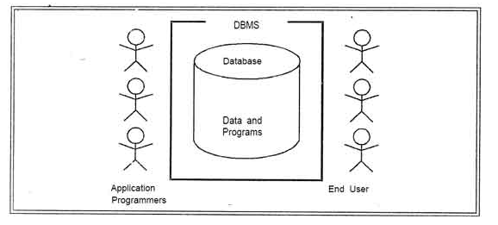

Fig: Components of Database System[2]

**Data**

It is the most important component of DBMS environment from the end users point of view. As shown in observes that data acts as a bridge between the machine components and the user components. The database contains the operational data and the meta-data, the 'data about data’. The database should contain all the data needed by the organization. One of the major features of databases is that the actual data are separated from the programs that use the data. A database should always be designed, built and populated for a particular audience and for a specific purpose.

**Hardware**

The hardware is the actual [computer](http://ecomputernotes.com/fundamental/introduction-to-computer/what-is-computer) system used for keeping and accessing the database. Conventional DBMS hardware consists of secondary storage devices, usually hard disks, on which the database physically resides, together with the associated Input-Output devices, device controllers and· so forth. Databases run on a' range of machines, from Microcomputers to large mainframes. Other hardware issues for a DBMS includes database machines, which is hardware designed specifically to support a database system.

**Software**

 The software is the actual DBMS. Between the physical database itself (i.e. the data as actually stored) and the users of the system is a layer of software, usually called the Database Management System or DBMS. All requests from users for access to the database are handled by the DBMS. One general function provided by the DBMS is thus the shielding of database users from complex hardware-level detail.

The DBMS allows the users to communicate with the database. In a sense, it is the mediator between the database and the users. The DBMS controls the access and helps to maintain the consistency of the data. Utilities are usually included as part of the DBMS. Some of the most common utilities are report writers and application development

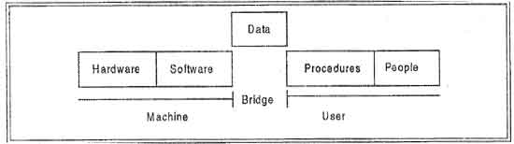

Fig: Software acting as bridge [3]

**Users**

There are a number of users who can access or retrieve data on demand using the applications and interfaces provided by the DBMS. Each type of user needs different software capabilities. The users of a database system can be classified in the following groups, depending on their degrees of expertise or the mode of their interactions with the DBMS. The users can be:

• Naive Users

• Online Users

• Application Programmers

• Sophisticated Users

• Data Base Administrator (DBA)

**Naive Users**

Naive Users are those users who need not be aware of the presence of the database system or any other system supporting their usage. Naive users are end users of the database who work through a menu driven application program, where the type and range of response is always indicated to the user. A user of an Automatic Teller Machine (ATM) falls in this category. The user is instructed through each step of a transaction. He or she then responds by pressing a coded key or entering a numeric value. The operations that can be performed by valve users are very limited and affect only a precise portion of the database. For example, in the case of the user of the Automatic Teller Machine, user's action affects only one or more of his/her own accounts.

**Online Users**

Online users are those who may communicate with the database directly via an online terminal or indirectly via a user interface and application program. These users are aware of the presence of the database system and may have acquired a certain amount of expertise with in the limited interaction permitted with a database.

**Sophisticated Users**

Such users interact with the system without ,writing programs.Instead, they form their requests in database query language. Each such query is submitted to a very processor whose function is to breakdown DML statement into instructions that the storage manager understands.

**Specialized Users**

Such users are those, who write specialized database application that do not fit into the fractional data-processing framework. For example: Computer-aided design systems, knowledge base and expert system, systems that store data with complex data types (for example, graphics data and audio data).

**Application Programmers**

Professional programmers are those who are responsible for developing application programs or user interface. The application programs could be written using general purpose programming language or the commands available to manipulate a database.

**Database Administrator**

The database administrator (DBA) is the person or group in charge for implementing the database system ,within an organization. The "DBA has all the system privileges allowed by the DBMS and can assign (grant) and remove (revoke) levels of access (privileges) to and from other users. DBA is also responsible for the evaluation, selection and implementation of DBMS package.[4]

**Data Communication Manager**

Data communication is application that simply communicates between user/client and database/server. It

**Refrences**

[1] <http://www.cse.ust.hk/~wilfred/Bobby/public_html/report/node22.html>

[2]<http://ecomputernotes.com/images//thumb553-Cothe%20Database%ystem%20Environment-925811ca4819fcb15f34e4d168df4e73.jpg>

[3]<http://ecomputernotes.com/images//thumb553-BRI705b44232a6b2c378925ae3179333fef.jpg>

[4] http://ecomputernotes.com/fundamental/what-is-a-database/advantages-and-disadvantages-of-dbms